Załącznik 6
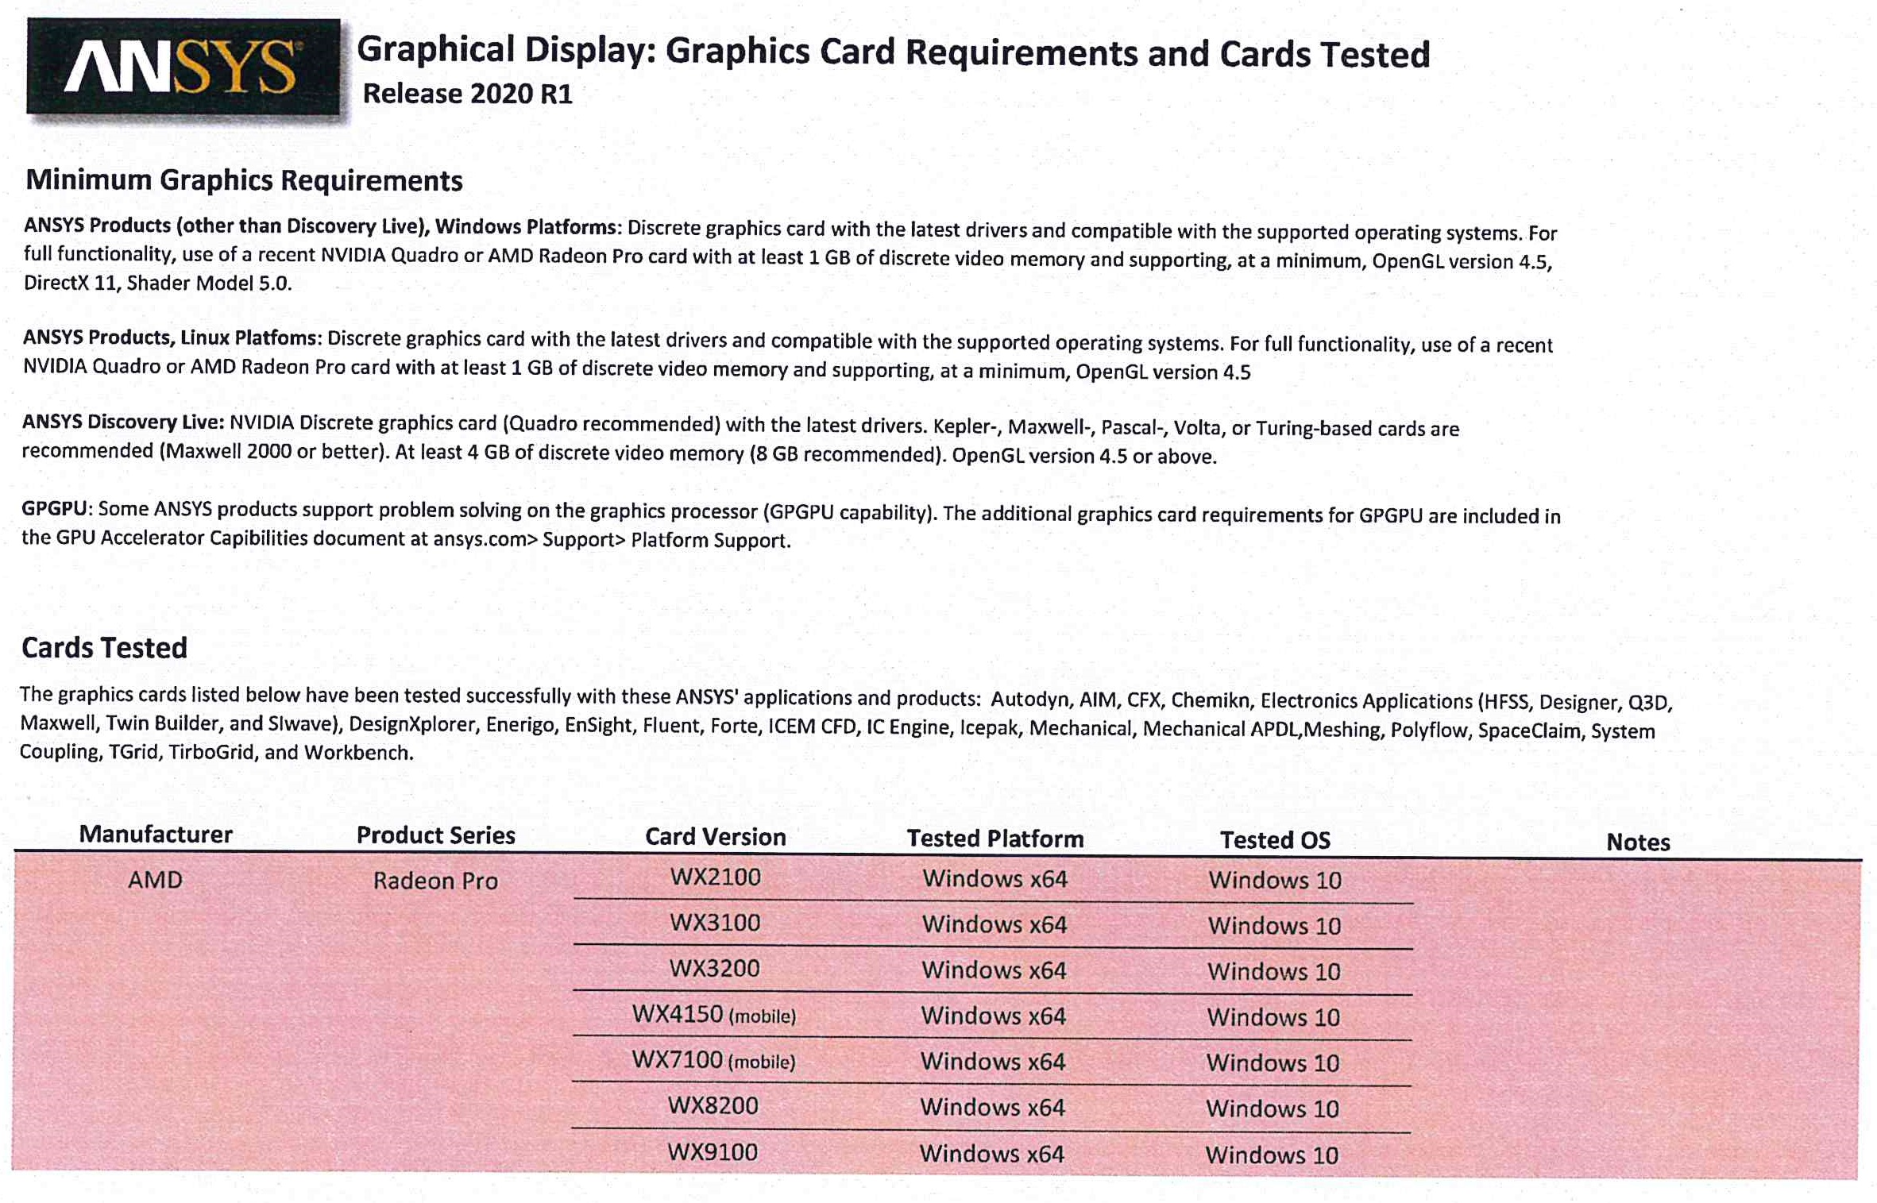

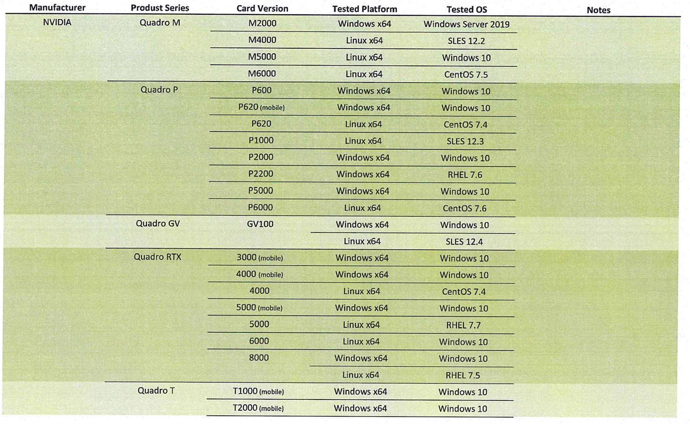
https://www.ansys.com/content/dam/it-solutions/platform-support/previous-releases/graphical-display-graphics-cards-tested-2020-r1.pdf?la=en&hash=6FAC80890F2CFFD6B74DE7B3361ABA7AE96B035C (źródło)

